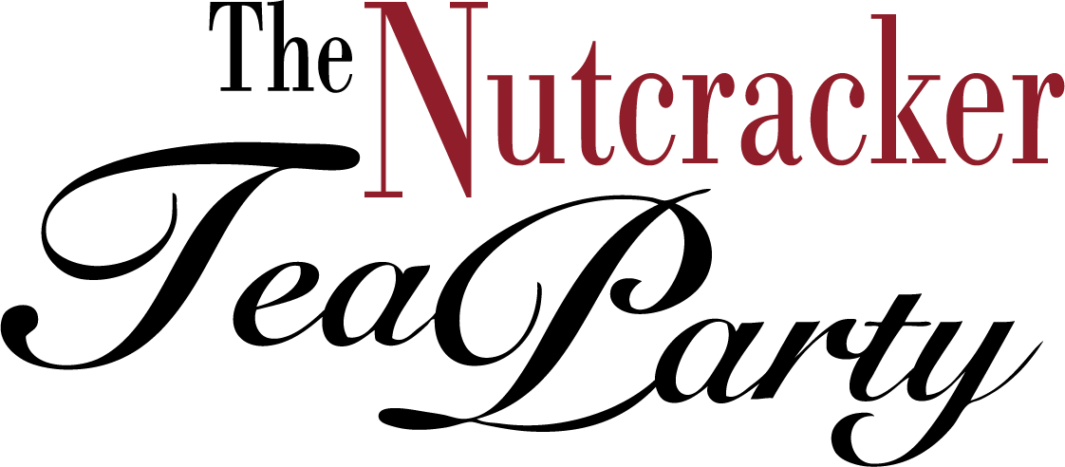

Nutcracker Inspired Original Art Contest Entry Form

Email form and a photo of your art to foa@artsandrec-op.org.

Submission Deadline: December 31, 2020

ARTIST’S NAME:

ARTIST’S AGE:

PARENT’S NAME:

EMAIL ADDRESS AT WHICH WE CAN REACH ARTIST:

PHONE NUMBER:

ABOUT YOUR ART

TITLE:

SIZE:

MEDIUM:

