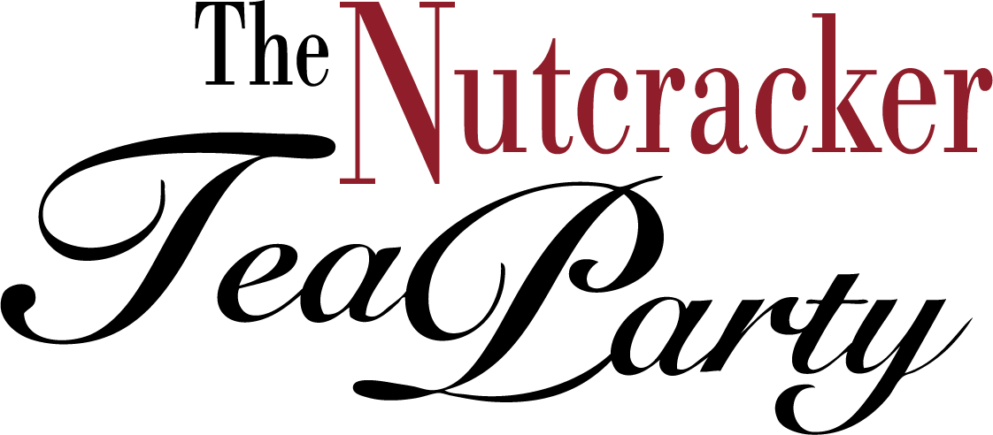

Nutcracker Coloring Contest Entry Form

Email form and your coloring to foa@artsandrec-op.org.

Submission Deadline: December 31, 2020

ARTIST’S NAME:

ARTIST’S AGE:
(Coloring Contest winners will be selected by age.)

PARENT’S NAME:

EMAIL ADDRESS AT WHICH WE CAN REACH ARTIST:

PHONE NUMBER:

